Machine Learning Note (Matlab/Octave, Andrew Ng, Stanford U.)

1. ML: Introduction

Definition:

1. the field of study that gives computers the ability to learn without being explicitly programmed
2. A computer program P is said to learn from Experience E with respect to some class of tasks T and performance measure P, if its performance at task in T, as measured by P, improves with experience E

* Supervised Learning
* Regression – predict result in continuous output
* Classification – predict in discrete output/categories
* Unsupervised Learning – no idea on how result will look like
* Clustering
* Non-Clustering

1. Linear regression with one variable
2. Hypothesis function: $h_{θ}\left(x\right)= θ_{0}+θ_{1}x$
3. Random guess $θ_{0}$ and $θ_{1}$
4. Cost function (mean of squared error, ½ is only for convenience):
$$J\left(θ_{0}, θ_{1}\right)= \frac{1}{2m}\sum_{i=1}^{m}{{{(h}_{θ}\left(x_{i}\right)-y_{i})}^{2}}$$

5. Gradient Descent

Iteration:

* Measure the accuracy
* Automatically improve

$θ_{j}:=θ_{j}- α\frac{∂}{∂θ_{j}}J\left(θ_{0}, θ_{1}\right)$ (for j = 0, 1)

for linear regression:

$\frac{∂}{∂θ_{0}}J\left(θ_{0}, θ_{1}\right)$ = $\frac{∂}{∂θ_{0}} \left[\frac{1}{2m}\sum_{i=1}^{m}{{{(h}_{θ}\left(x_{i}\right)-y_{i})}^{2}}\right]$

= $\frac{1}{2m}*\frac{∂}{∂θ_{0}} \left[\sum_{i=1}^{m}{{(θ_{0}+θ_{1}x_{i}-y_{i})}^{2}}\right]$

= $\frac{1}{m}*\sum_{i=1}^{m}{{(θ}_{0}+θ_{1}x_{i}-y_{i})}$

$\frac{∂}{∂θ_{1}}J\left(θ_{0}, θ_{1}\right)$ = $\frac{∂}{∂θ_{1}} \left[\frac{1}{2m}\sum_{i=1}^{m}{{{(h}_{θ}\left(x_{i}\right)-y_{i})}^{2}}\right]$

= $\frac{1}{2m}*\frac{∂}{∂θ_{0}} \left[\sum_{i=1}^{m}{{(θ_{0}+θ_{1}x_{i}-y_{i})}^{2}}\right]$

= $\frac{1}{m}*\sum_{i=1}^{m}{{(θ}_{0}+θ_{1}x_{i}-y_{i})}x_{i}$

thus, repeat till convergence: {

$θ_{0}:=θ_{0}- α\frac{1}{m}*\sum_{i=1}^{m}{{(θ}_{0}+θ_{1}x_{i}-y_{i})}$

$θ_{1}:=θ_{1}- α\frac{1}{m}*\sum_{i=1}^{m}{{(θ}_{0}+θ_{1}x_{i}-y_{i})*x_{i}}$

}

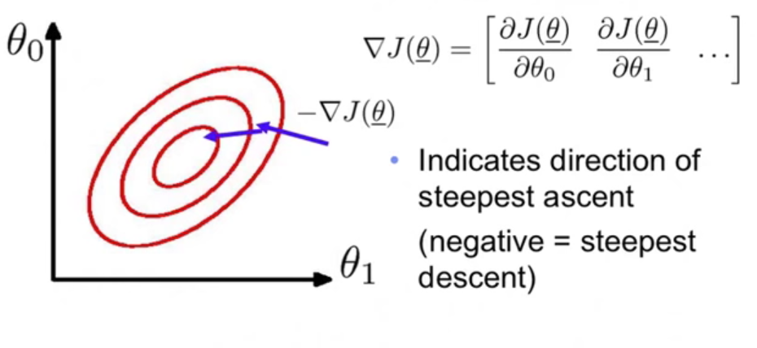

Finally, get the $θ_{0} and θ_{1}$ for the final linear hypothesis equation, it will be with the lowest error for existing dataset.

1. Linear regression with multiple variables

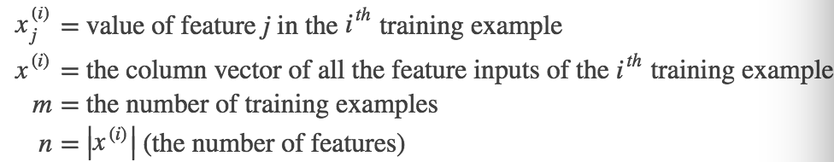

1. Hypothesis function: $h_{θ}\left(x\right)= θ_{0}+θ_{1}x_{1}+θ_{2}x_{2}+…+θ_{n}x_{n}$

Or vectorized:

$$h_{θ}\left(X\right)= θ^{T}X$$

or, if X stored with features varied by columns: X is m x (n+1), theta will be (n+1) x 1

$h_{θ}\left(X\right)= Xθ$

a m x 1 matrix of predictions in all X cases

1. Random guess $θ_{i}$
2. Cost function (mean of squared error, ½ is only for convenience):

$$J\left(θ\right)= \frac{1}{2m}\sum_{i=1}^{m}{{{(h}_{θ}\left(x^{(i)}\right)-y^{(i)})}^{2}}$$

or vectorized:

$J\left(θ\right)= \frac{1}{2m}{(Xθ-\overset{⃑}{y})}^{T}(Xθ-\overset{⃑}{y})$

**- a number of total cost**

1. Gradient Descent

Iteration:

* Measure the accuracy
* Automatically improve

$θ_{j}:=θ_{j}- α\frac{∂}{∂θ_{j}}J\left(θ\right)$ (for j = 0, 1,2,3…n)

for linear regression:

$\frac{∂}{∂θ_{0}}J\left(θ\right)$ = $\frac{∂}{∂θ_{0}} \left[\frac{1}{2m}\sum_{i=1}^{m}{{{(h}_{θ}\left(x^{(i)}\right)-y^{(i)})}^{2}}\right]$

$\frac{∂}{∂θ_{1}}J\left(θ\right)$ = $\frac{∂}{∂θ_{1}} \left[\frac{1}{2m}\sum_{i=1}^{m}{{{(h}_{θ}\left(x_{i}\right)-y_{i})}^{2}}\right]$

thus, repeat till convergence: {

$θ_{0}:=θ_{0}- α\frac{1}{m}*\sum_{i=1}^{m}{{(h}_{θ}\left(x^{\left(i\right)}\right)-y^{\left(i\right)})}*x_{0}^{(i)}$

$θ_{1}:=θ_{1}- α\frac{1}{m}*\sum_{i=1}^{m}{{(h}_{θ}\left(x^{\left(i\right)}\right)-y^{\left(i\right)})}*x_{1}^{(i)}$

$……$ from 0 to n

}

or vectorized:

repeat: {

$θ := θ- α∇J(θ)$

}

$$∇J\left(θ\right)={[\frac{∂}{∂θ_{0}}J\left(θ\right) ,\frac{∂}{∂θ_{1}}J\left(θ\right),\frac{∂}{∂θ_{2}}J\left(θ\right)……\frac{∂}{∂θ_{n}}J\left(θ\right)]}^{T}$$

$$\frac{∂}{∂θ_{j}}J\left(θ\right)= \frac{1}{m}*\sum_{i=1}^{m}{{(h}_{θ}\left(x^{\left(i\right)}\right)-y^{\left(i\right)})}*x_{j}^{(i)}$$

thus, gradient descent could be written as:

$$θ := θ- \frac{α}{m}X^{T}(Xθ-\overset{⃑}{y})$$

(by dimension, $θ:(n+1)*$ 1 X: m*(n+1) ( $Xθ-Y):m*1$)

In practice, we use:

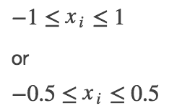

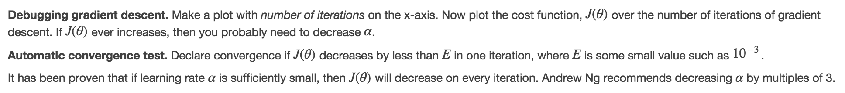

If without iteration, we use Normal Equation

$$θ ={ {(X}^{T}X)}^{-1}X^{T}y$$

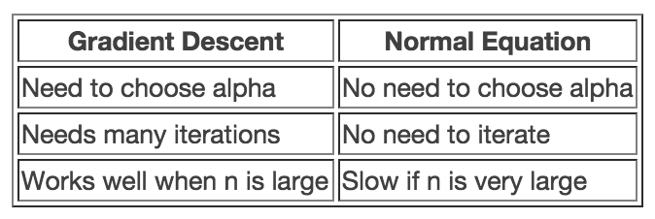

1. Logistic Regression

…

1. Neuron Networks
2. Model representation

At a very simple level, neurons are basically computational units that take input (**dendrites**) as electrical input (called "spikes") that are channeled to outputs (**axons**).

1 layer:

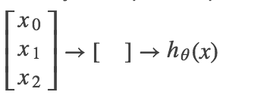

In neural networks however we sometimes call it a sigmoid (logistic) **activation** function.

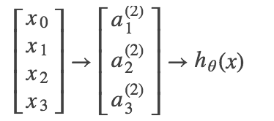



or $a^{(1)}={g(Θ}^{(1)}X)$

X – 4x1 vertical a – 3x1 $Θ-3x4$

Steps of NN:

S1 – Choose arch:

1. Number of input units = dimension of features x(i)
2. Number of output units = number of classes
3. Number of unites per layer (the more, the better when computation cost allows)
4. Usually 1 hidden layer, If 1+, then same number in each layer

S2 – Training NN:

1. Randomly initialize weights
2. Implement the forward propagation to get $h_{θ}(x^{(i)})$
$$a^{(1)}={g(Θ}^{(1)}X)$$

$$a^{\left(l\right)}={g(Θ}^{\left(l-1\right)}a^{\left(l-1\right)})$$

$$h={g(Θ}^{\left(L-1\right)}a^{\left(L-1\right)})$$

3. Implement the cost function based on theta above

$$J\left(Θ\right)= -\frac{1}{m}\sum_{i=1}^{m}{\sum_{k=1}^{K}{\left\{y_{k}^{\left(i\right)}{\log\left[h_{θ}\left(x^{\left(i\right)}\right)\right]}_{k}+\left(1-y_{k}^{\left(i\right)}\right)\log{{\left[1-h_{θ}\left(x^{\left(i\right)}\right)\right]}_{k}}\right\}}}$$

$$+ \frac{λ}{2m} \sum_{l=1}^{L-1}{\sum_{t=1}^{S_{l}}{\sum_{j=1}^{S_{l+1}}{θ_{j,t}^{(l)}}}}$$

* K: number of classes, for y(k)
* j has different meanings in 2 terms.

1. Implement back propagation to compute partial derivatives

* Goal: minimize $J\left(Θ\right)$

1. Use gradient descent or a built-in optimization function to minimize the cost function with the weights in theta

Iterate to loop on every training example:

for i = 1:m

Perform forward propagation and back propagation using example x(i), y(i)

(Get activations a(l) and delta terms d(l) for l = 2, ….L)